Assessment 2: BlackJack Program, Marks 50

Due: Monday 14th December 11.55pm

Create a program which mimics a game of BlackJack or 21. The rules are you need to have a hand less than or equal to 21. An Ace is worth 11 and Jack, Queen and King are all worth 10. The dealer deals you two cards and you can decide to stick or twist. You can receive a card until you stick or go bust (over 21). When you have decided to stick the dealer deals two cards. If he has less than 17 he takes another card and repeats until he has more than 17 or is bust. You then compare your score with the dealers, the highest wins.

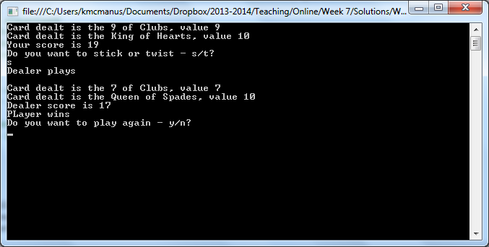

|  |  |
| --- | --- |
| Task | Marks |
| Use of methods | 10 |
| Use of arrays | 10 |
| Random | 5 |
| Loops | 5 |
| Selection | 5 |
| Appropriate types (int, bool etc) | 5 |
| Algorithm | 10 |
| Clarity of code (Space, comments, naming) | 5 |
| Functions as it should with test data | 10 |
| Formatting of output | 5 |
| Use of Classes/Objects | 30 |
|  |  |
|  | 100 |